Lab Assignment No: 01

NAME: Vivek Pundkar ROLLNO: 77

CLASS: C BRANCH: ENTC BATCH: 3

-----------------------------------------------------------------------------------------------------------------------------------------

Problem statement:

Create a database with appropriate constraints using DDL and populate/modify it with the help of DML.

The following database diagram illustrates the HR sample database: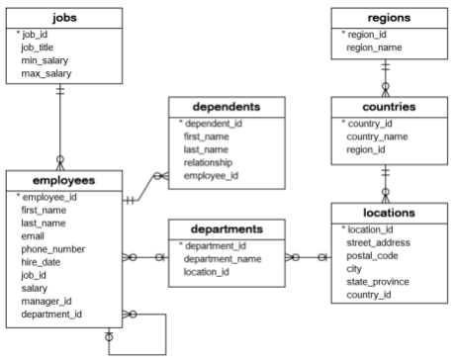

Ref: https://www.sqltutorial.org/sql-sample-database/

In the 1st Session

Using SQL statements (No graphic Tool use)….

1. Create employees , jobs and departments table for HR database. 2. Add or Insert appropriate number of records in all the tables in step1

In the 3rdsession

Create all the tables shown in the HR schema and insert the appropriate number of records in all the tables

|  |  |
| --- | --- |
| Job_id | Job_title Min_Sal Max_sal |
| 12 | Programmer 40000 100000 |
| 13 | Sr_programmer 100000 250000 |

Create table jobs

(job_idint(2) ,job_title varchar(15) , Max_sal int(6), Min_sal int(6));

Insert into jobs

Values(12, ‘Programmer’,40000,100000);

**HR database**:

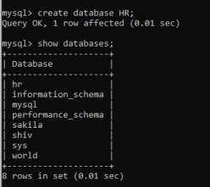

**Creating tables of HR_DATABASE:**

**1] jobs table:**

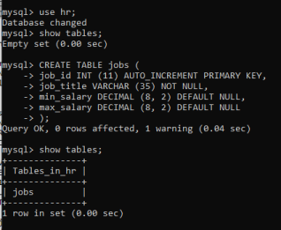**Insert into jobs**

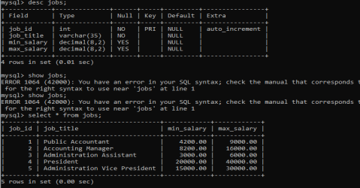**2]countries table:**

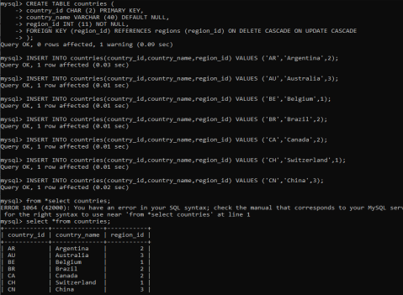

**3]locations table:**

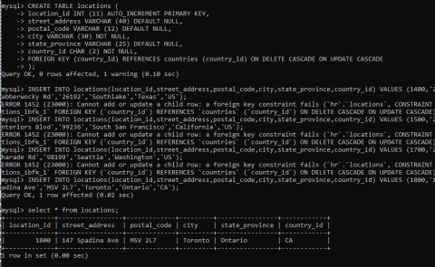**4]Employee table:**

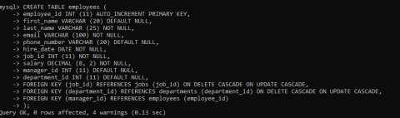**Insert into employee**

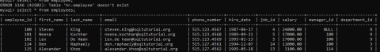

**5]departments table:**

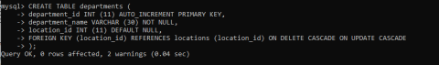

**Insert into department**

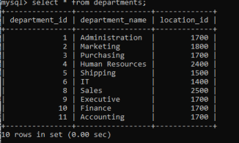

**6]regions table:**

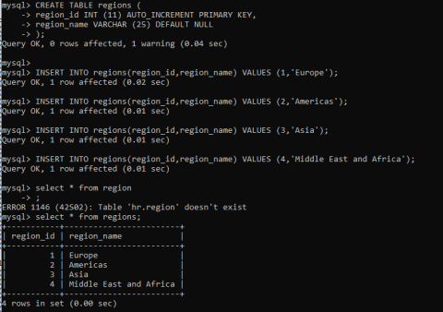**7]Dependents table:**

